1. Dashboard

--- not showing any data and not match any field ([link](https://aptest.therssoftware.com/apollointlcrm/public/admin/dashboard))

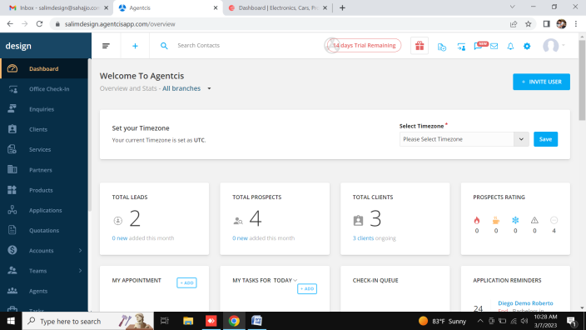 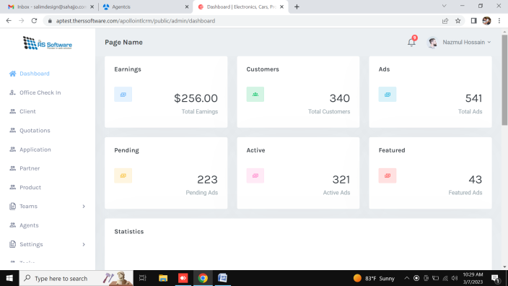

1. Office Check In

Done Office Check In list ([link](https://aptest.therssoftware.com/apollointlcrm/public/admin/officevisit/waiting))

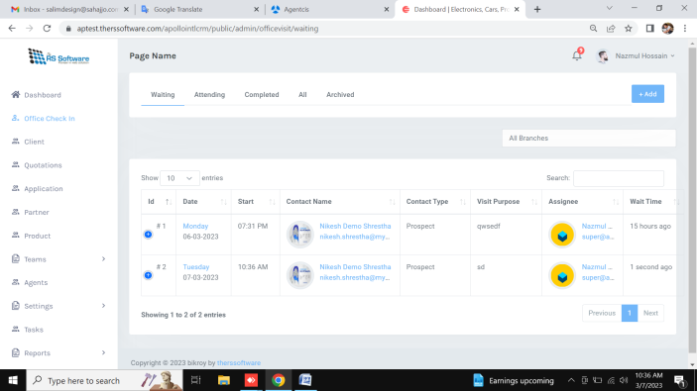 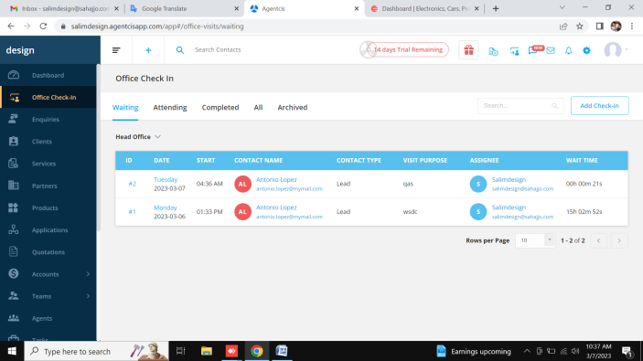

Done Create Office Check-In ([link](https://aptest.therssoftware.com/apollointlcrm/public/admin/officevisit/waiting))

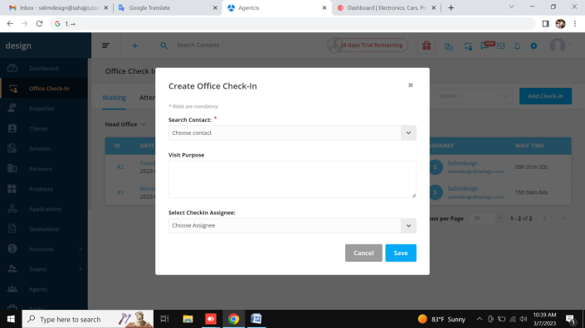 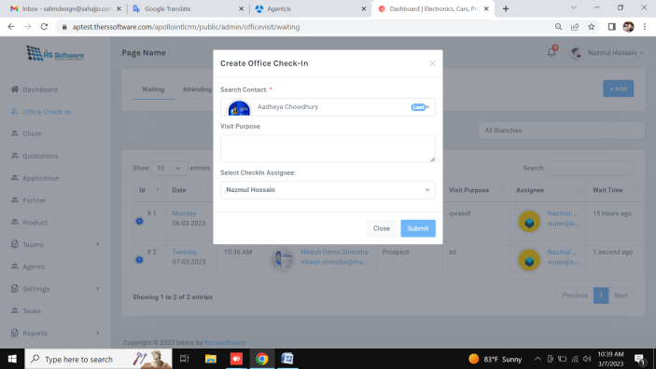

Create Office Check-In validation not working ([link](https://aptest.therssoftware.com/apollointlcrm/public/admin/officevisit/waiting))

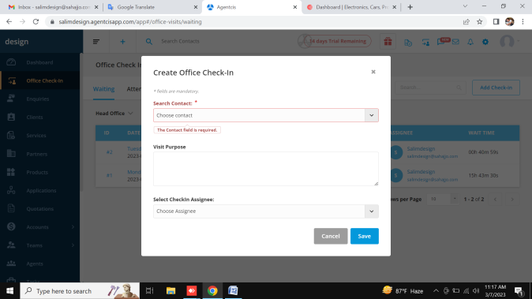 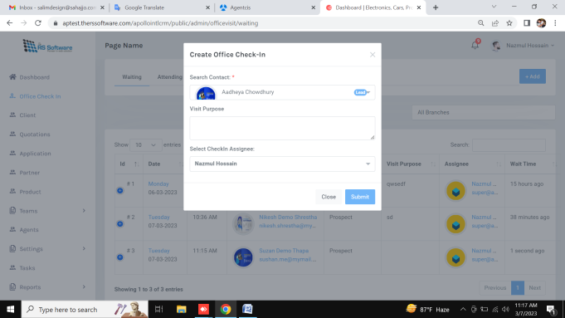

Office Check-In link not working ([link](https://aptest.therssoftware.com/apollointlcrm/public/admin/officevisit/waiting))

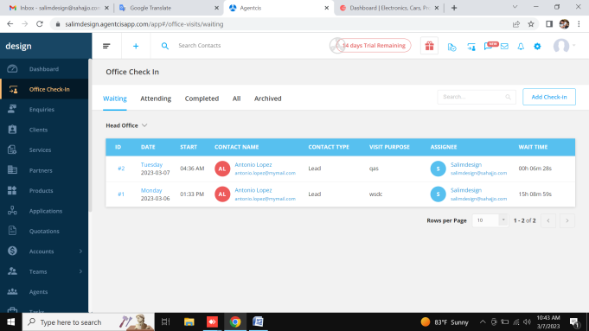 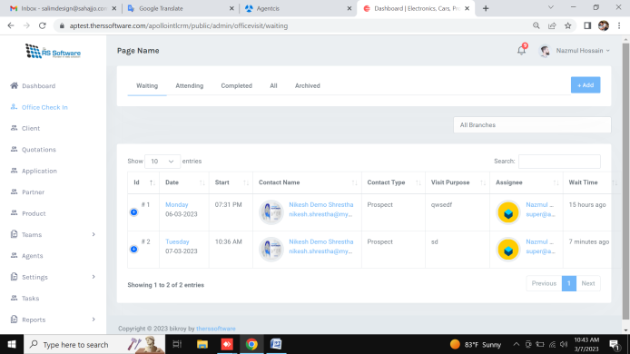

Office Check-In all tab link not showing all data([link](https://aptest.therssoftware.com/apollointlcrm/public/admin/officevisit/waiting))

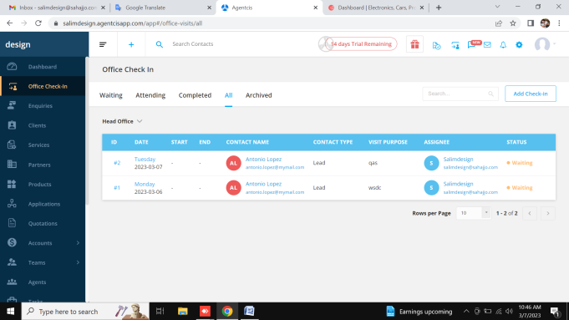 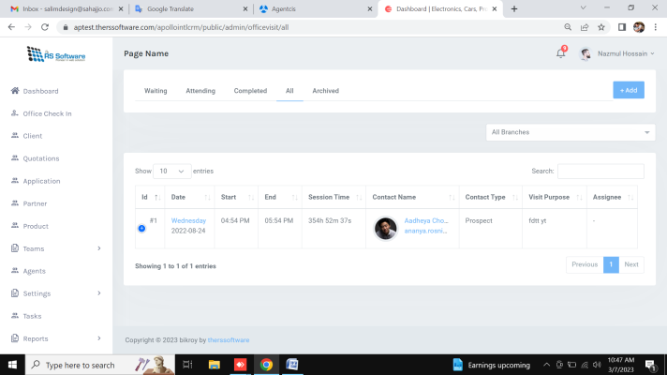

Office Check-In edit and delete button not need ([link](https://aptest.therssoftware.com/apollointlcrm/public/admin/officevisit/waiting))

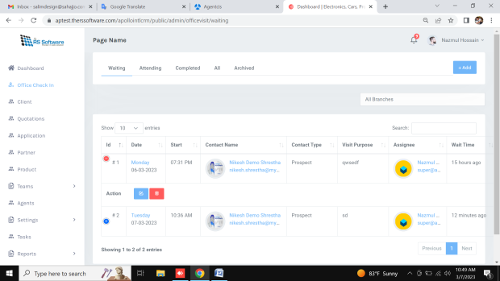 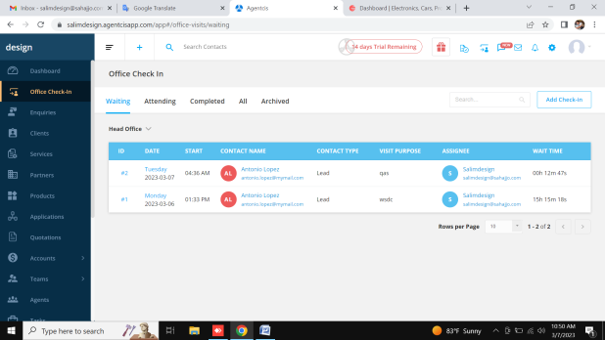

1. Enquiries not add this page

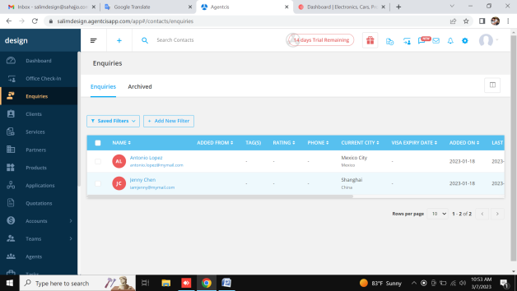

1. Clients

Done Clients List Page ([link](https://aptest.therssoftware.com/apollointlcrm/public/admin/client/clients))

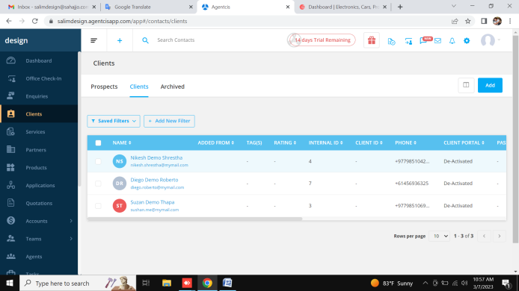 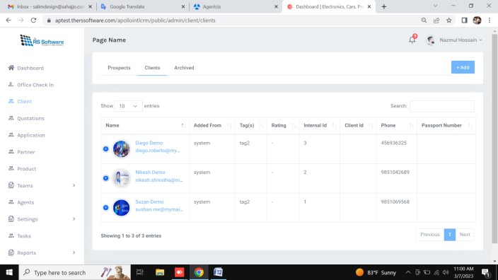

Add Clients not working ([link](https://aptest.therssoftware.com/apollointlcrm/public/admin/client/add) )

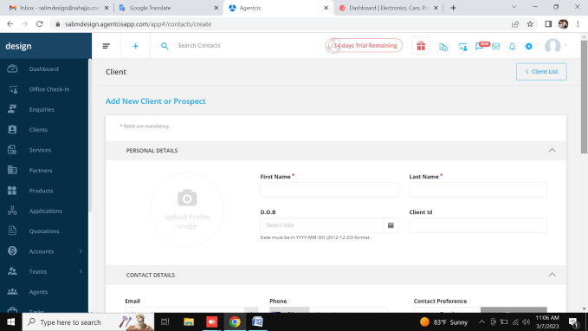 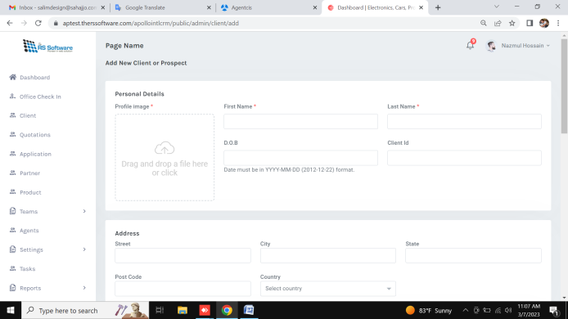

Clients Details page activity not working ([link](https://aptest.therssoftware.com/apollointlcrm/public/admin/client/profile/activities/3) )

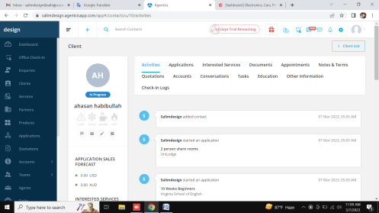 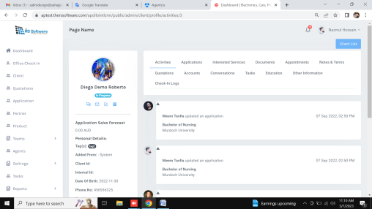

Clients Details page add application not working ([link](https://aptest.therssoftware.com/apollointlcrm/public/admin/client/profile/activities/3) )

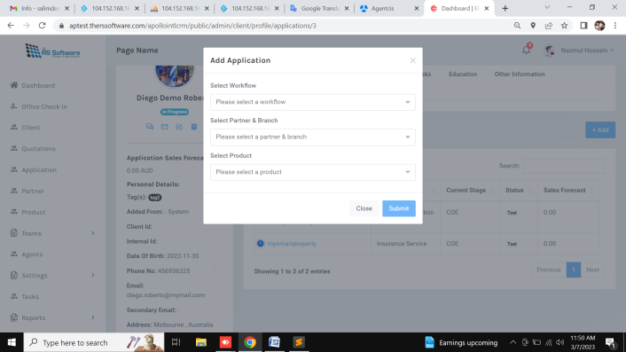 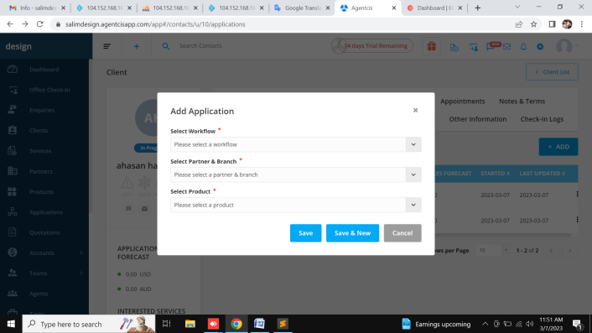

Clients Details page application Details not working ([link](https://aptest.therssoftware.com/apollointlcrm/public/admin/client/profile/activities/3) )

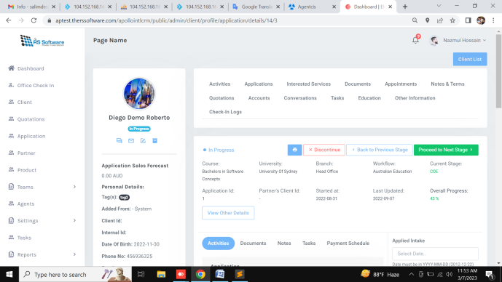 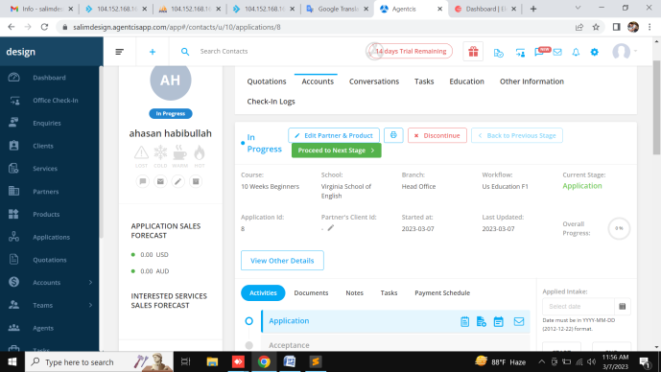

Clients Details page Interested Services not working ([link](https://aptest.therssoftware.com/apollointlcrm/public/admin/client/profile/services/3) )

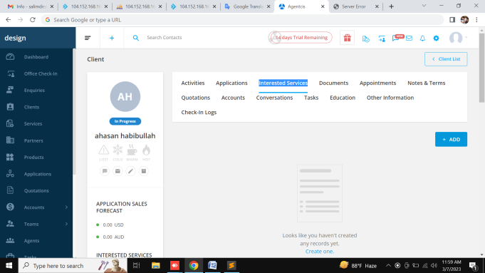 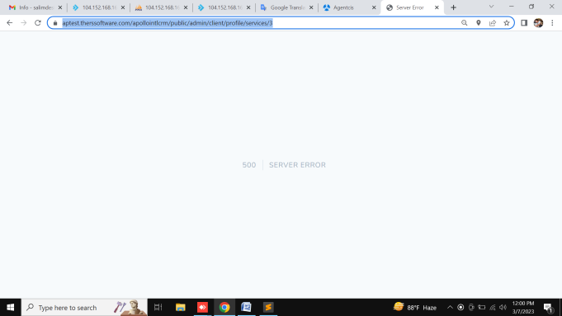

Done Clients Details page Documents ([link](https://aptest.therssoftware.com/apollointlcrm/public/admin/client/profile/documents/3) )

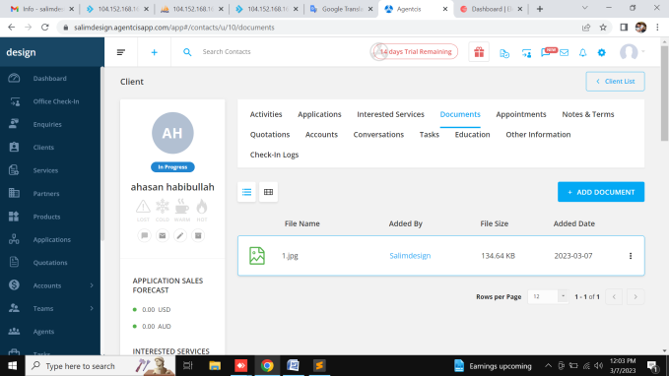 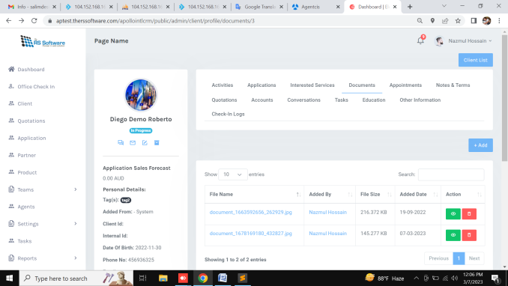

Done Clients Details page Appointments ( [link](https://aptest.therssoftware.com/apollointlcrm/public/admin/client/profile/documents/3) )

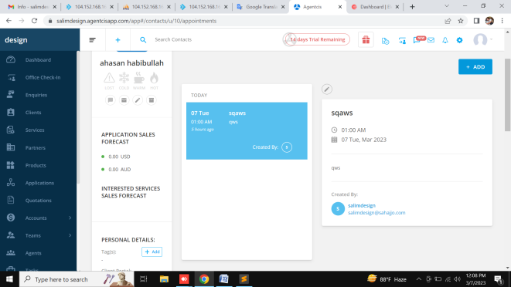 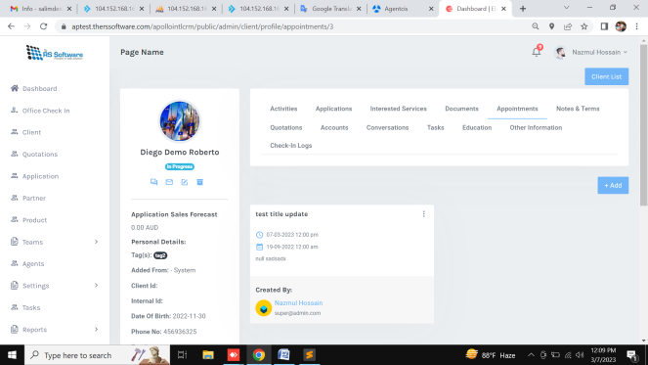

Done Clients Details page Appointments edit and add ( [link](https://aptest.therssoftware.com/apollointlcrm/public/admin/client/profile/documents/3) )

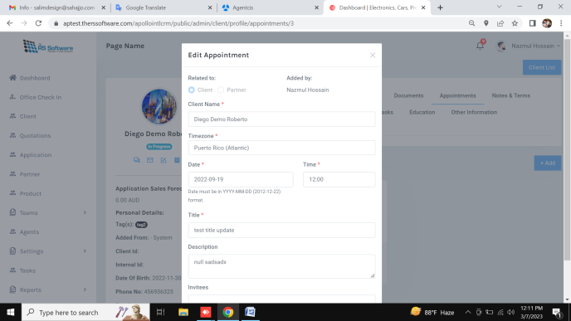 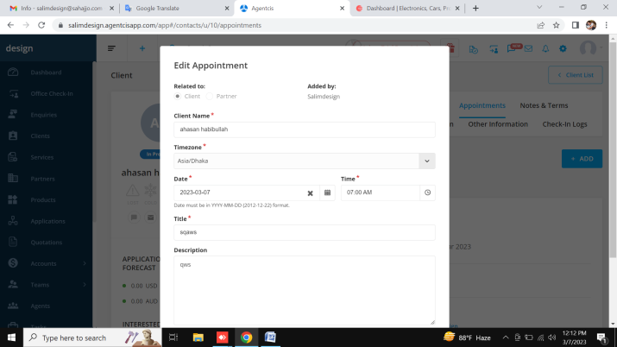

Clients Details page Appointments edit and add invites field not working ( [link](https://aptest.therssoftware.com/apollointlcrm/public/admin/client/profile/documents/3) )

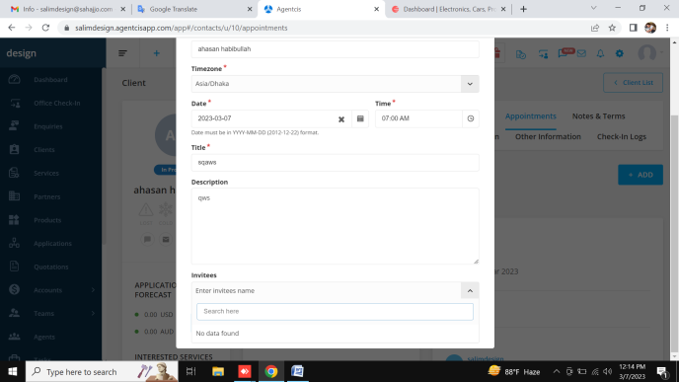

Done Clients Details page Notes & Terms ( [link](https://aptest.therssoftware.com/apollointlcrm/public/admin/client/profile/documents/3) )

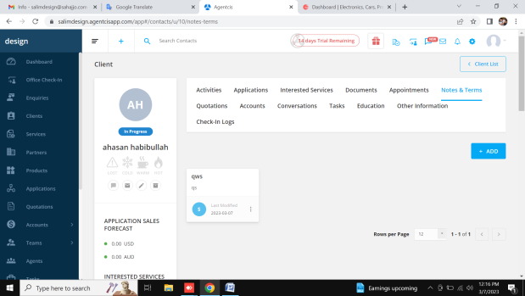 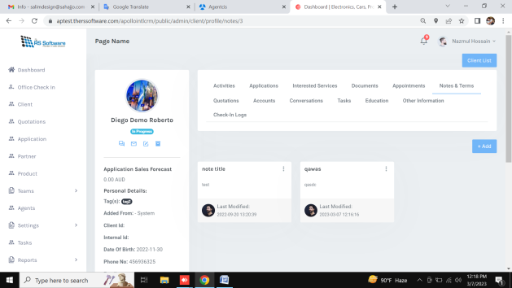

Clients Details page Quotations not working ( [link](https://aptest.therssoftware.com/apollointlcrm/public/admin/client/profile/documents/3) )

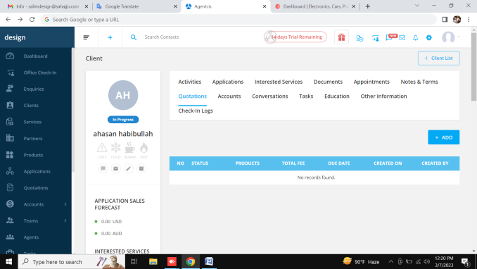 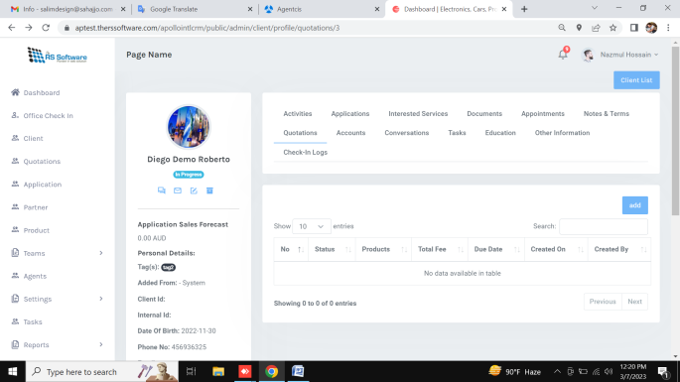

Clients Details page Accounts not working ( [link](https://aptest.therssoftware.com/apollointlcrm/public/admin/client/profile/documents/3) )

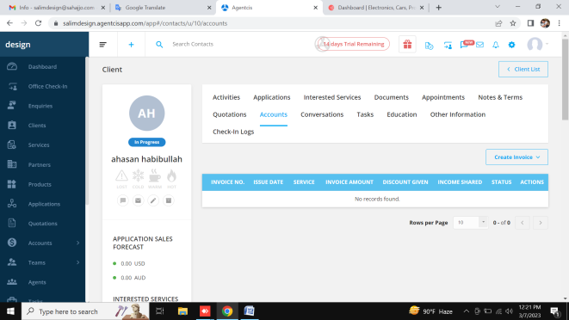 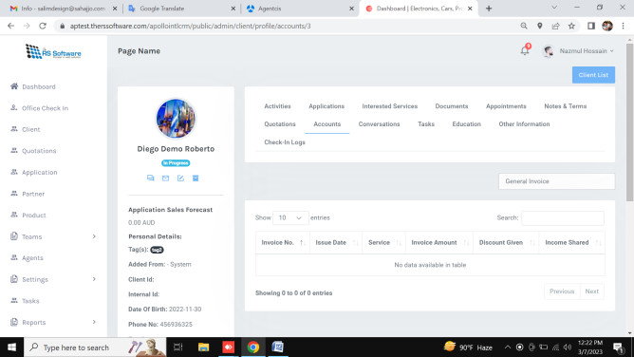

Clients Details page Conversations not working ( [link](https://aptest.therssoftware.com/apollointlcrm/public/admin/client/profile/documents/3) )

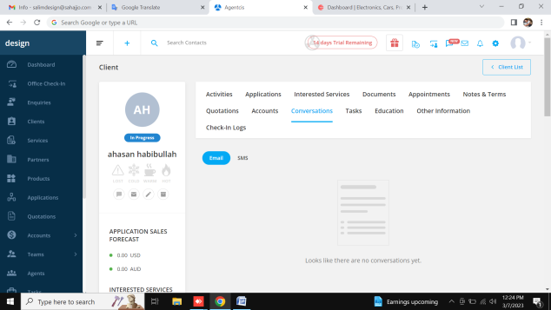 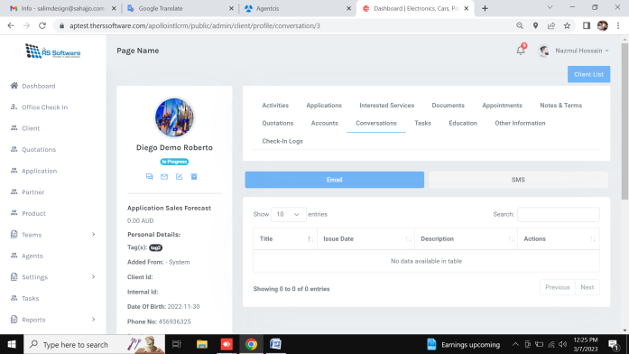

Done Clients Details page Tasks ( [link](https://aptest.therssoftware.com/apollointlcrm/public/admin/client/profile/documents/3) )

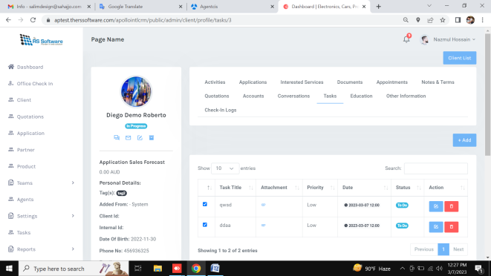 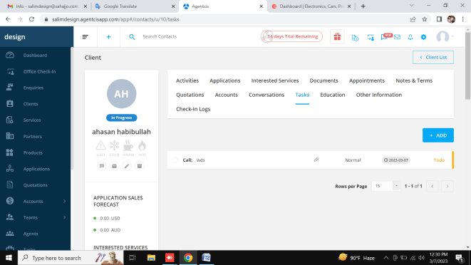

Clients Details page Tasks not need this button ( [link](https://aptest.therssoftware.com/apollointlcrm/public/admin/client/profile/documents/3) )



Done Clients Details page Education ( [link](https://aptest.therssoftware.com/apollointlcrm/public/admin/client/profile/documents/3) )

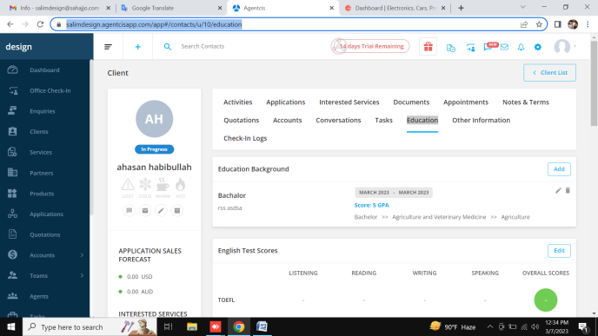 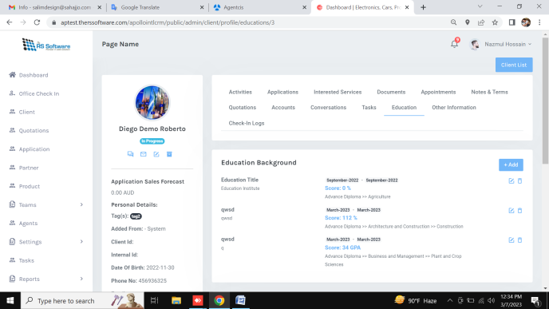

Clients Details page Other Information not working ( [link](https://aptest.therssoftware.com/apollointlcrm/public/admin/client/profile/documents/3) )

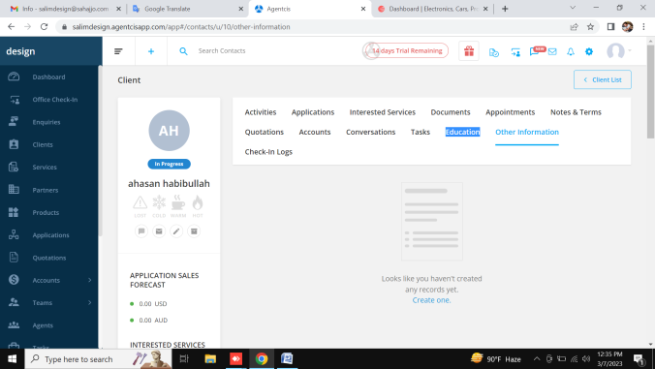 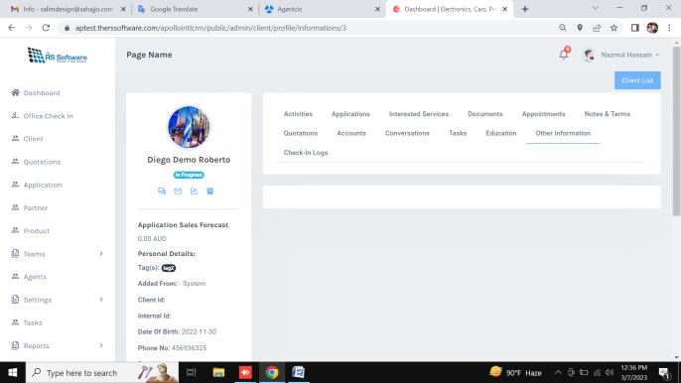

Clients Details page Check-In Logs not working ( [link](https://aptest.therssoftware.com/apollointlcrm/public/admin/client/profile/documents/3) )

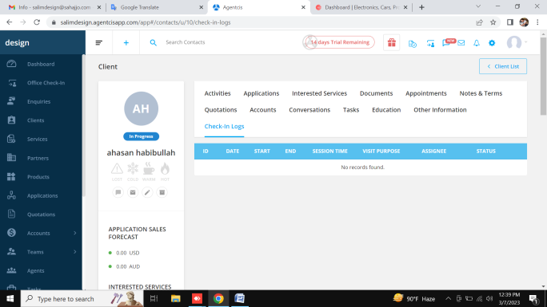 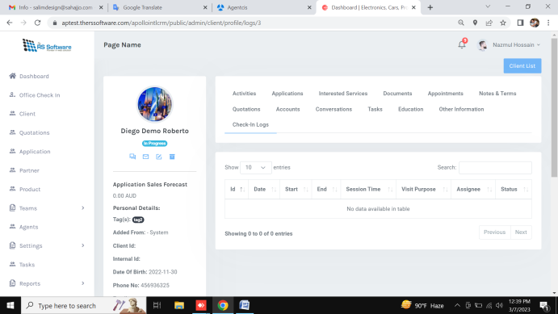

5. Quotation

Quotation not working ( [link](https://aptest.therssoftware.com/apollointlcrm/public/admin/quotations/active/list) )

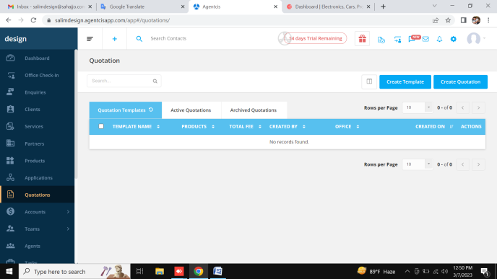 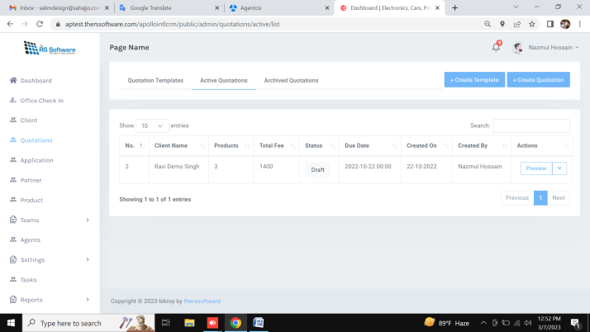

Edit Quotation not working ( [link](https://aptest.therssoftware.com/apollointlcrm/public/admin/quotations/active/edit/6) )

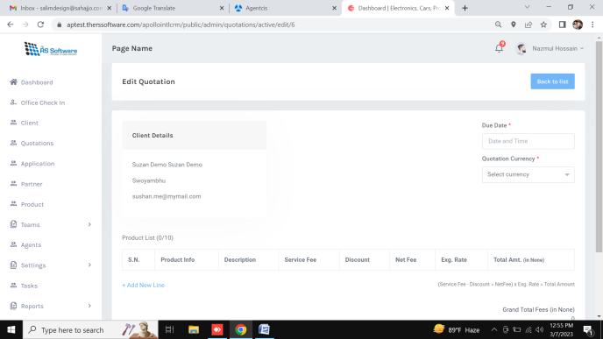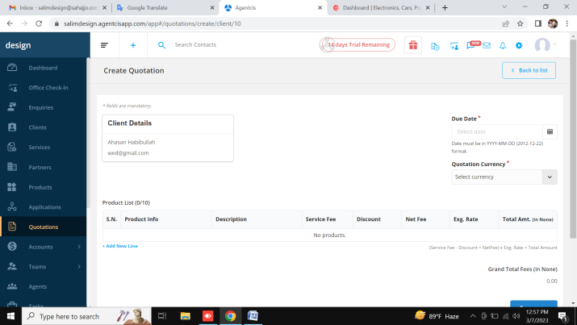

Quotation preview not working ( [link](https://aptest.therssoftware.com/apollointlcrm/public/admin/quotations/active/edit/6) )

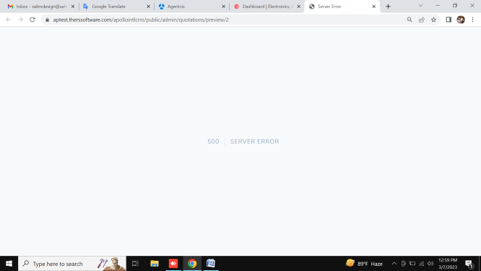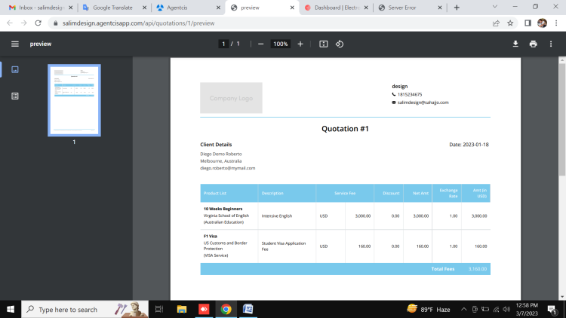

6. Applications

done Applications list page ( [link](https://aptest.therssoftware.com/apollointlcrm/public/admin/application/list) )

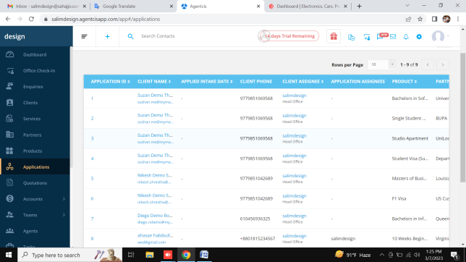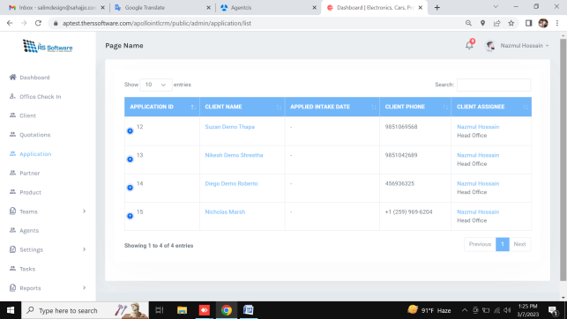

Applications list not show email address ( [link](https://aptest.therssoftware.com/apollointlcrm/public/admin/application/list) )



Applications list edit delete not working ( [link](https://aptest.therssoftware.com/apollointlcrm/public/admin/application/list) )

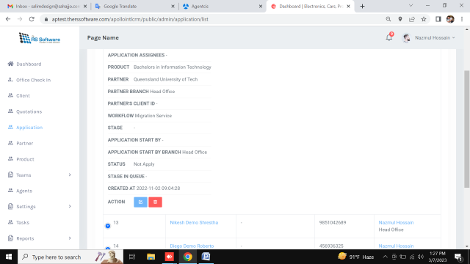 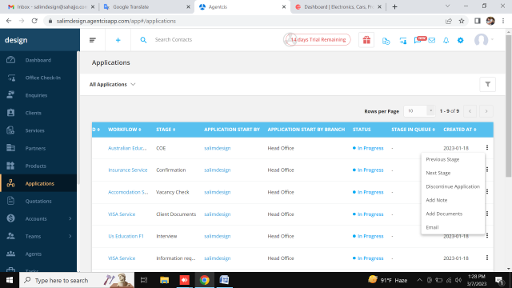

6. Partners

Done Partners list ( [link](https://aptest.therssoftware.com/apollointlcrm/public/admin/partner/list) )

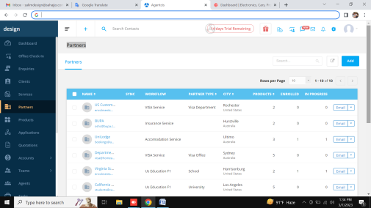 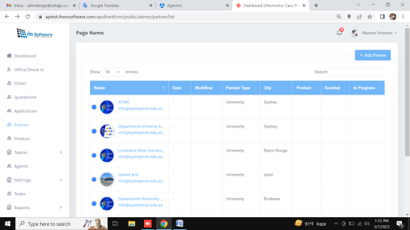

Done Add Partners ( [link](https://aptest.therssoftware.com/apollointlcrm/public/admin/partner/list) )

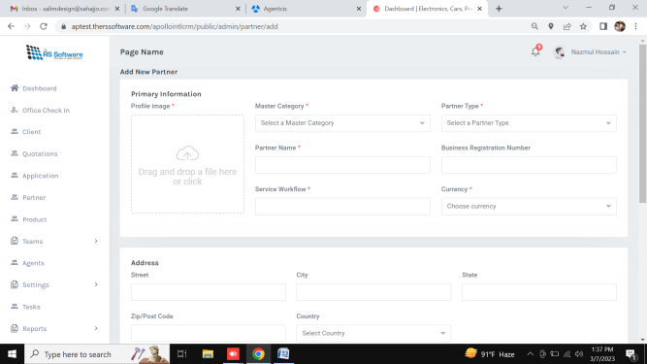 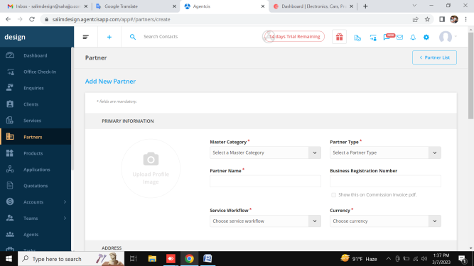

Done edit Partners ( [link](https://aptest.therssoftware.com/apollointlcrm/public/admin/partner/list) )

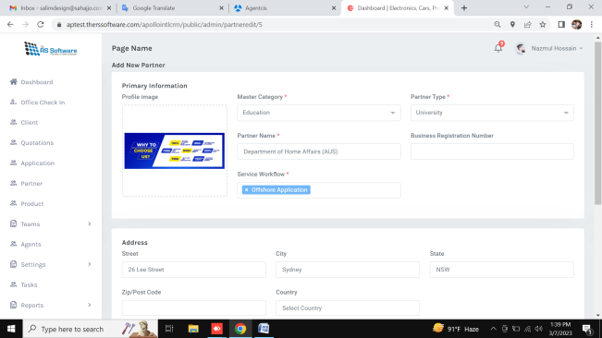 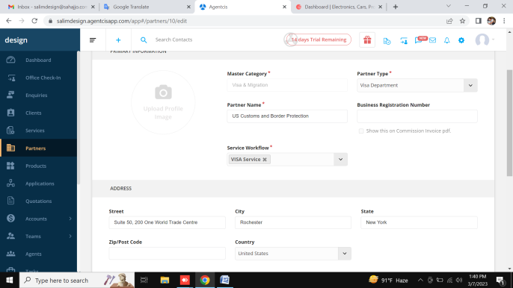

Partners details Applications not showing real data ( [link](https://aptest.therssoftware.com/apollointlcrm/public/admin/partner/profile/applications/5) )

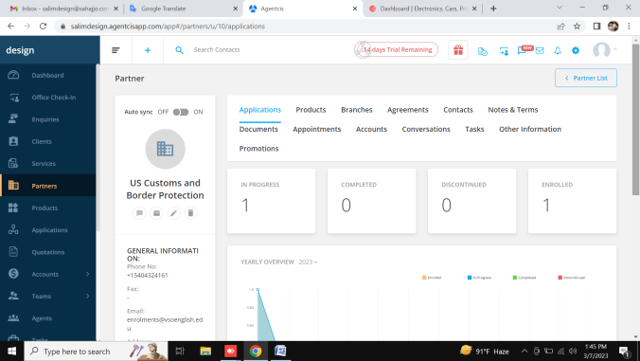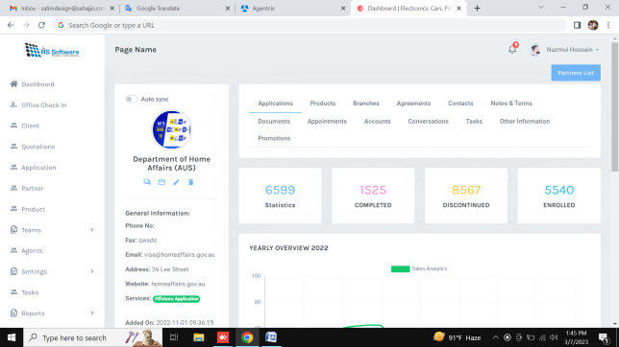

Partners details Products view button not showing ( [link](https://aptest.therssoftware.com/apollointlcrm/public/admin/partner/profile/applications/5) )

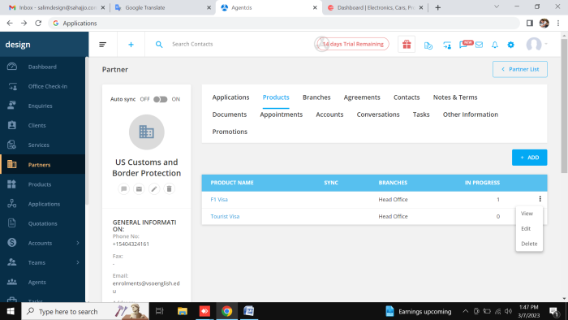 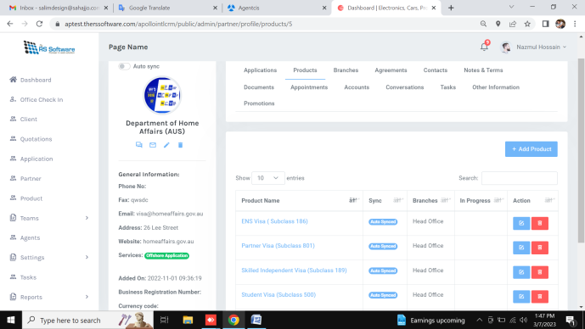

Done Partners details Add and edit ( [link](https://aptest.therssoftware.com/apollointlcrm/public/admin/partner/profile/applications/5) )

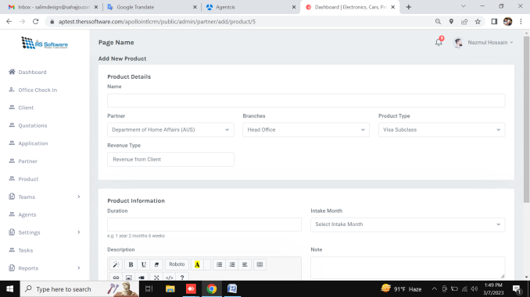 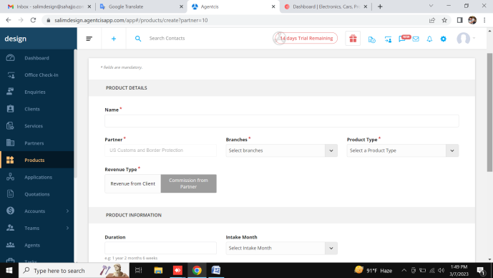

Done Partners details Branches add , edit, list ( [link](https://aptest.therssoftware.com/apollointlcrm/public/admin/partner/profile/branche/5) )

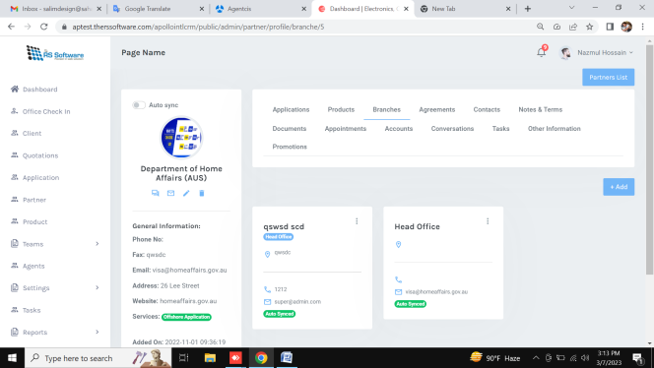 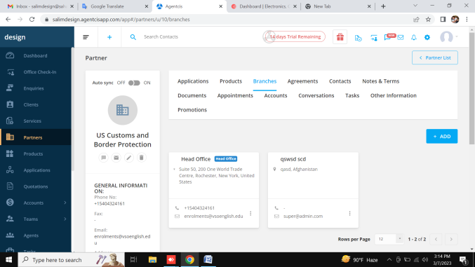

Partners details Agreements not working( [link](https://aptest.therssoftware.com/apollointlcrm/public/admin/partner/profile/branche/5) )

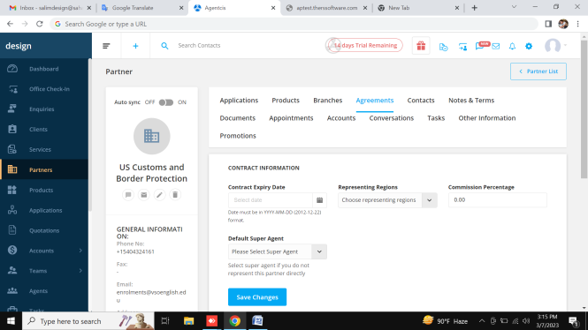 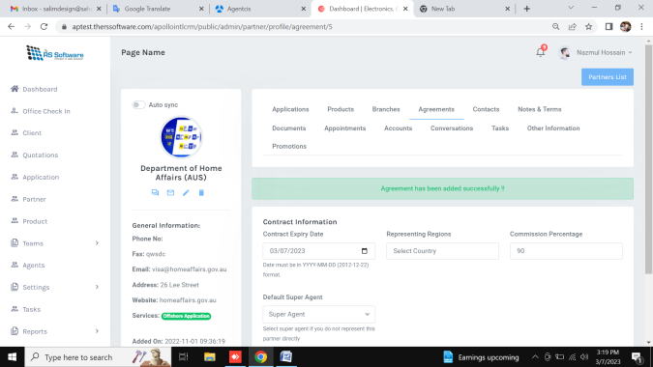

Done Partners details Contacts ( [link](https://aptest.therssoftware.com/apollointlcrm/public/admin/partner/profile/contact/5) )

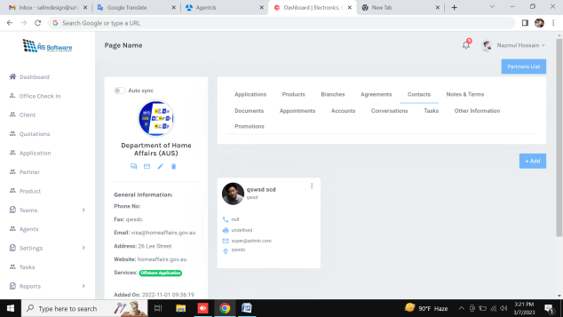 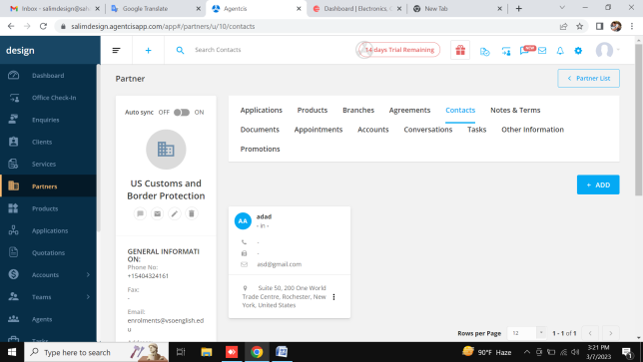

Done Partners details Notes & Terms ( [link](https://aptest.therssoftware.com/apollointlcrm/public/admin/partner/profile/note/5) )

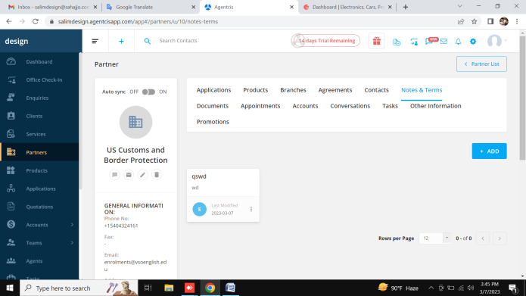 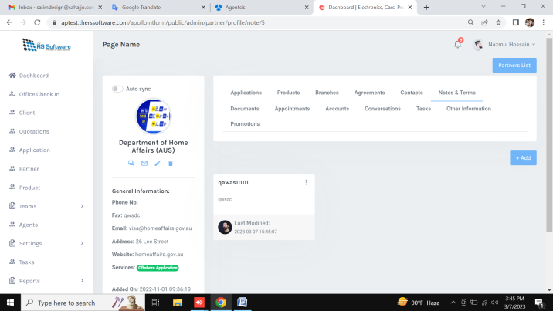

Done Partners details documents ( [link](https://aptest.therssoftware.com/apollointlcrm/public/admin/partner/profile/contact/5) )

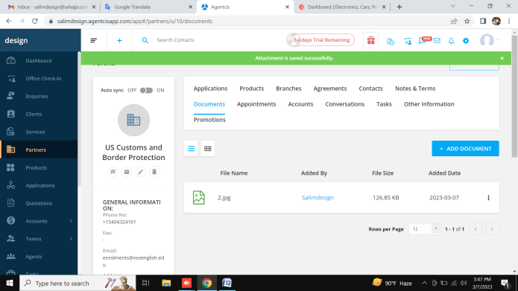 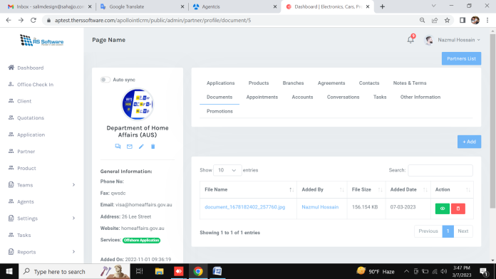

Done Partners details appointments ( [link](https://aptest.therssoftware.com/apollointlcrm/public/admin/partner/profile/contact/5) )

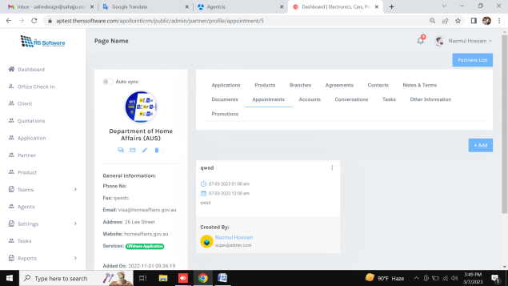 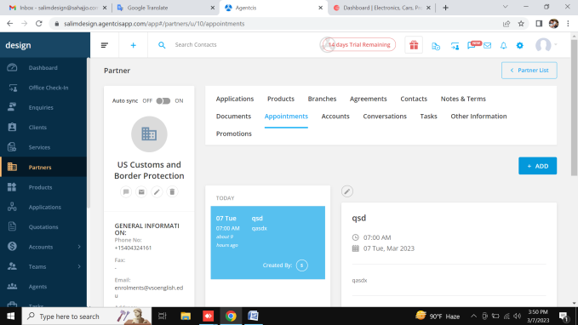

Partners details accounts not working ( [link](https://aptest.therssoftware.com/apollointlcrm/public/admin/partner/profile/contact/5) )

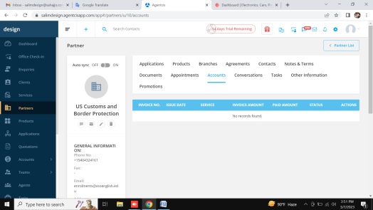 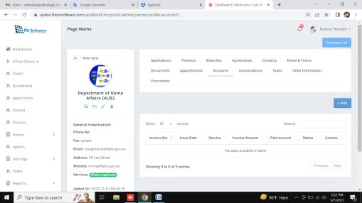

Partners details conversationsnot not working ( [link](https://aptest.therssoftware.com/apollointlcrm/public/admin/partner/profile/contact/5) )

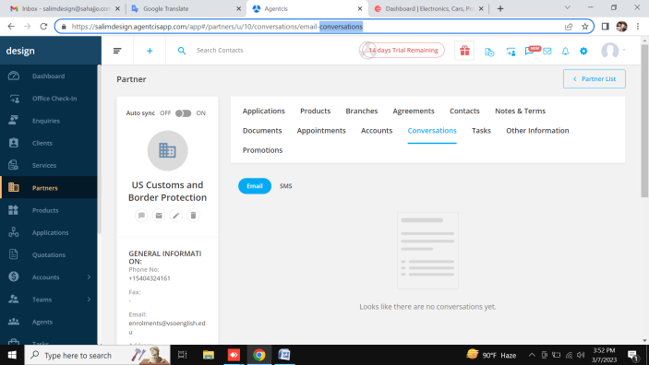 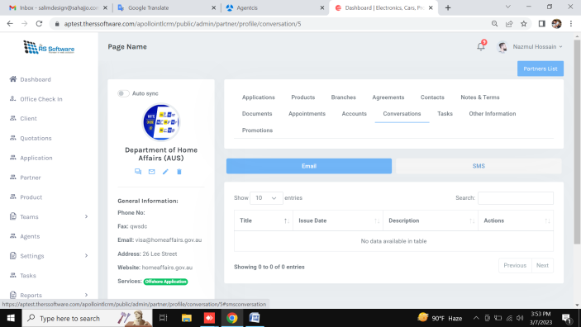

Done Partners details tasks ( [link](https://aptest.therssoftware.com/apollointlcrm/public/admin/partner/profile/contact/5) )

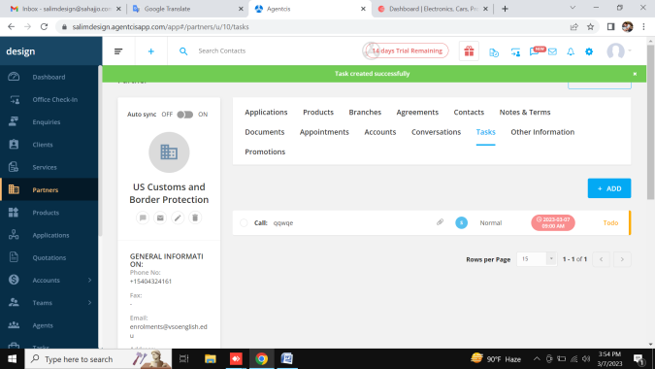 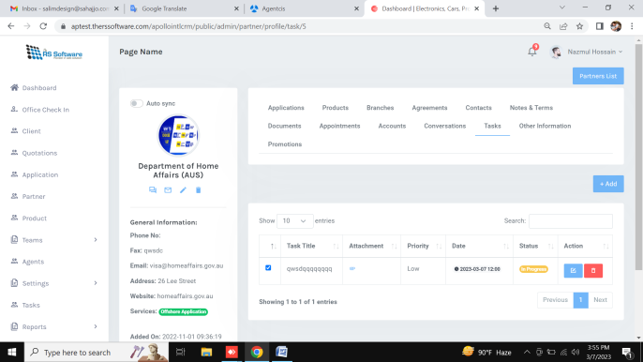

Partners details otherinformation not working ( [link](https://aptest.therssoftware.com/apollointlcrm/public/admin/partner/profile/contact/5) )

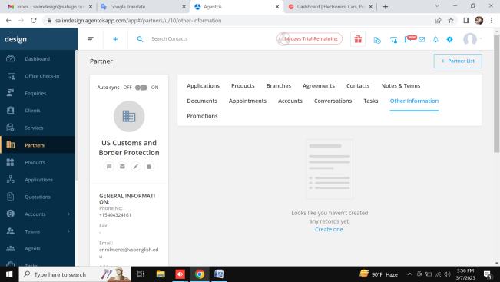 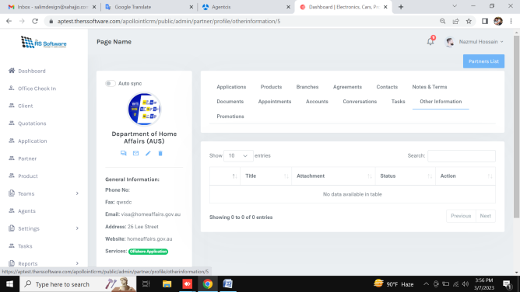

Done Partners details promotion ( [link](https://aptest.therssoftware.com/apollointlcrm/public/admin/partner/profile/contact/5) )

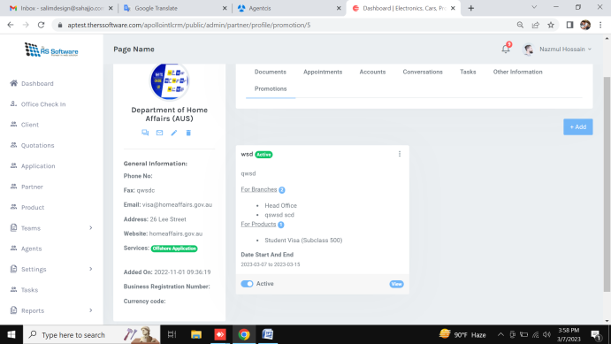 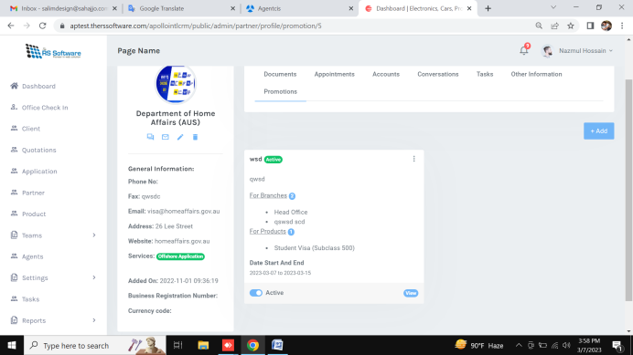

7. Products

Products not working

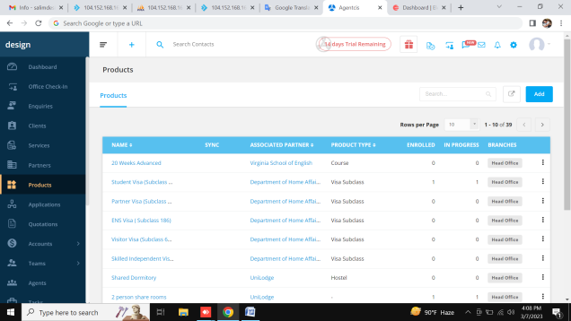 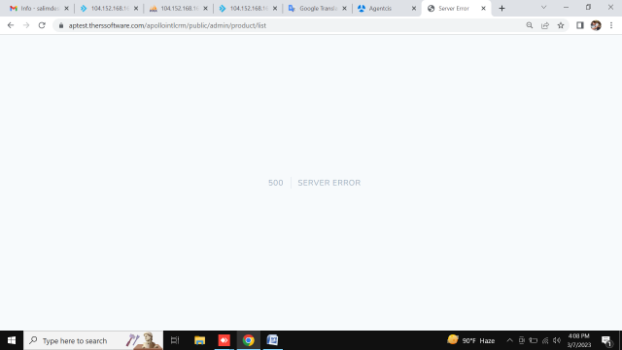

8. Teams

Teams tab active , inactive not working ( [link](https://aptest.therssoftware.com/apollointlcrm/public/admin/offices/list) )

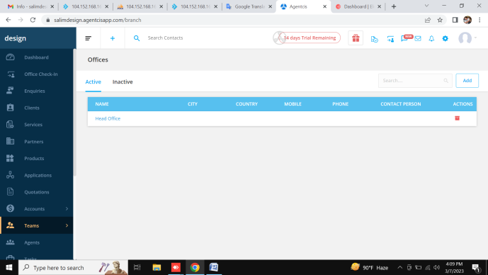 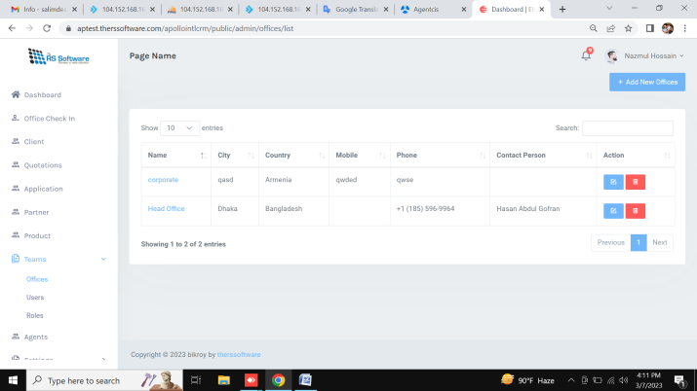

Done Teams list and add edit ( [link](https://aptest.therssoftware.com/apollointlcrm/public/admin/offices/list) )

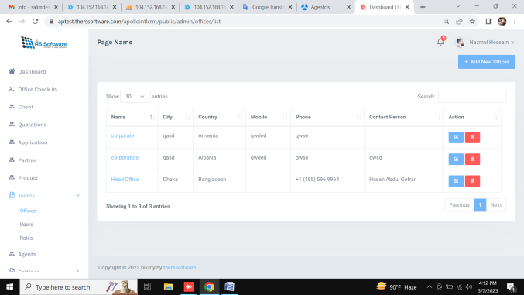 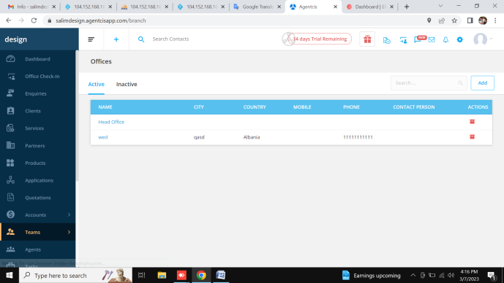

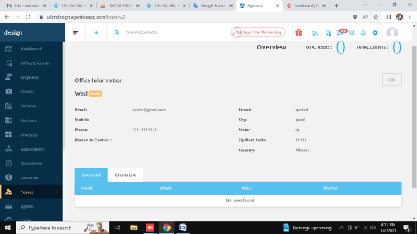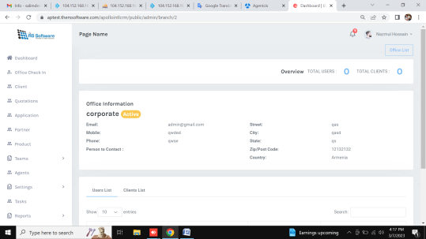

Done Teams users ( [link](https://aptest.therssoftware.com/apollointlcrm/public/admin/users/list) )

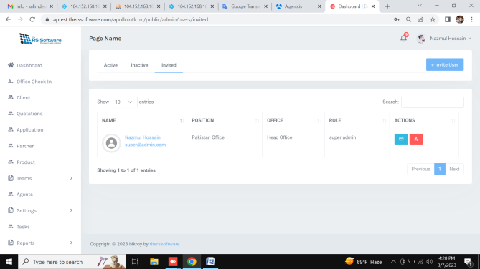 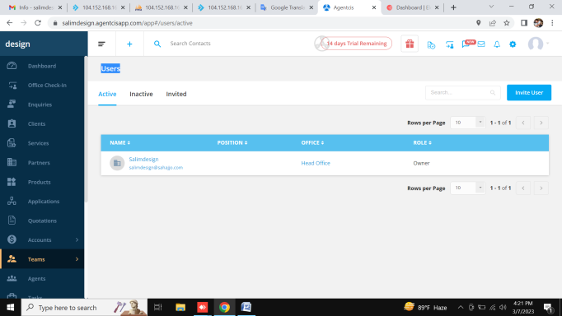

Teams users details any thing not working ( [link](https://aptest.therssoftware.com/apollointlcrm/public/admin/users/list) )

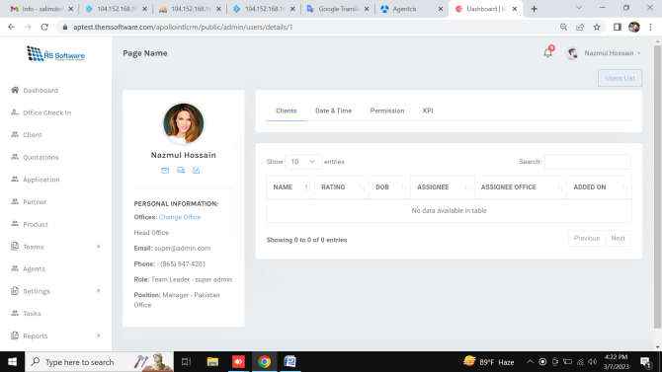 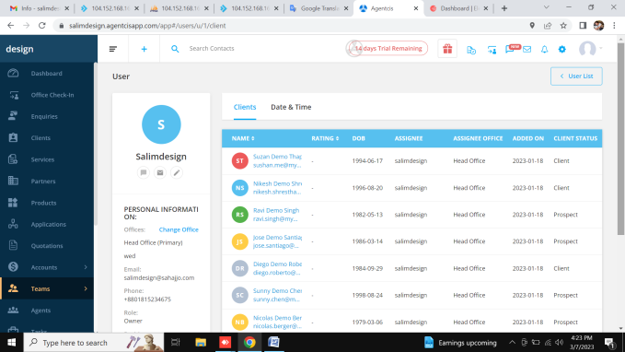

Done Teams users details edit ( [link](https://aptest.therssoftware.com/apollointlcrm/public/admin/users/list) )

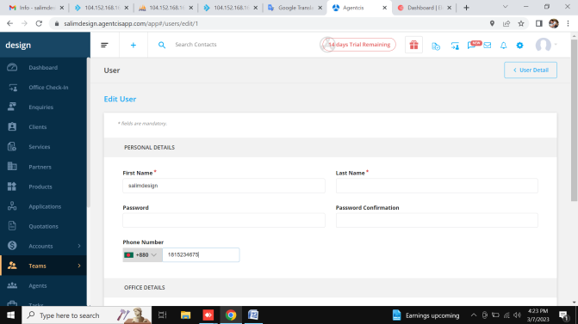 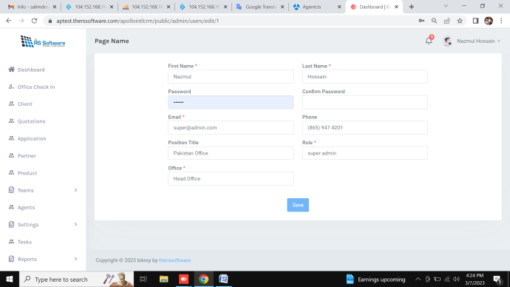

Teams users details email and sms not working ( [link](https://aptest.therssoftware.com/apollointlcrm/public/admin/users/list) )

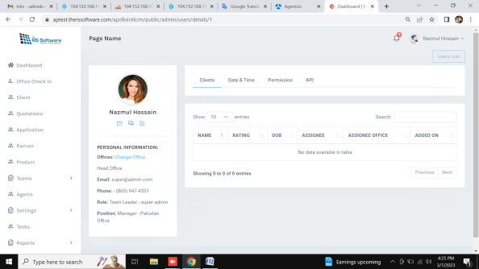 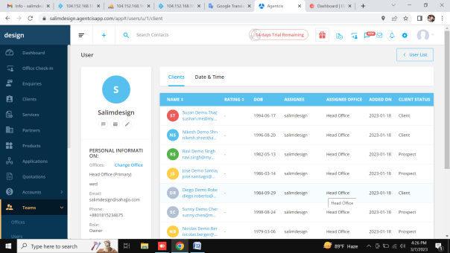

Teams users roles not working

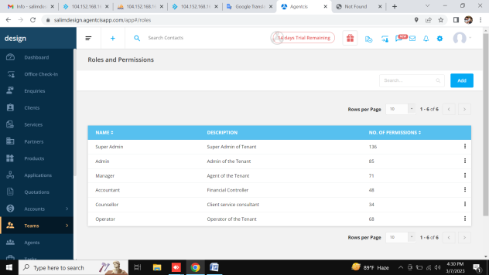 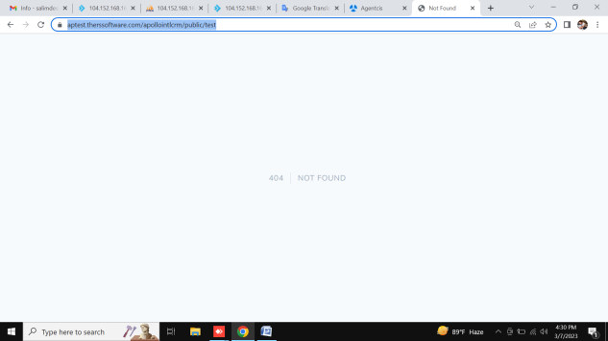

9. agents

Done Agents list add , edit

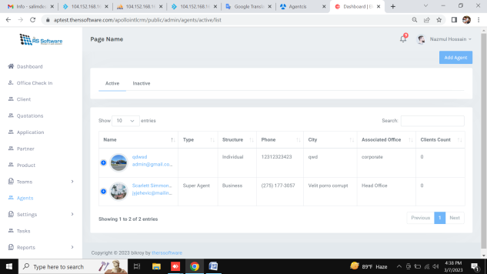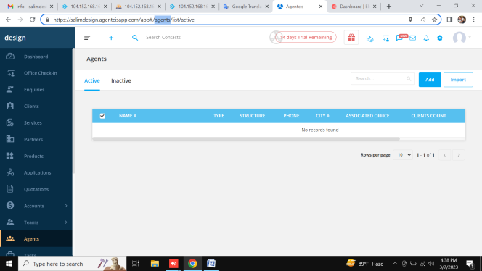

Agents list action not working

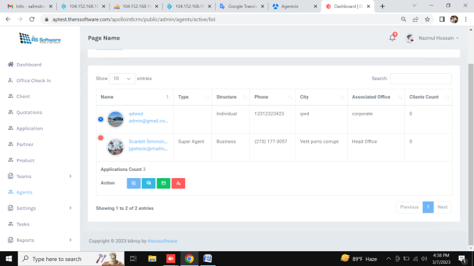

9. Settings

Done Settings Preferences ([link](https://aptest.therssoftware.com/apollointlcrm/public/admin/setting/prefarance/profile))

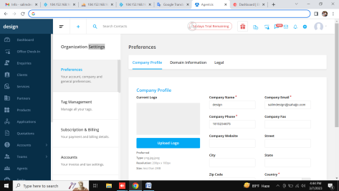 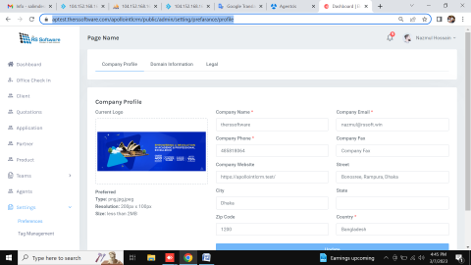

Done Settings Tags ([link](https://aptest.therssoftware.com/apollointlcrm/public/admin/setting/tag/management))

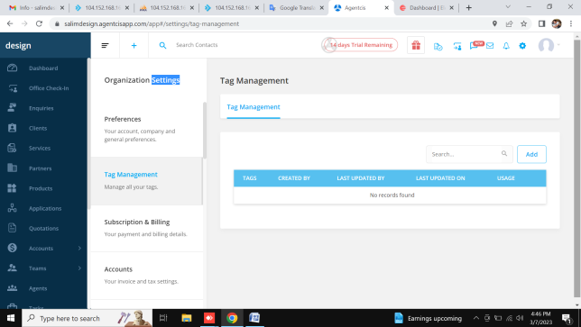 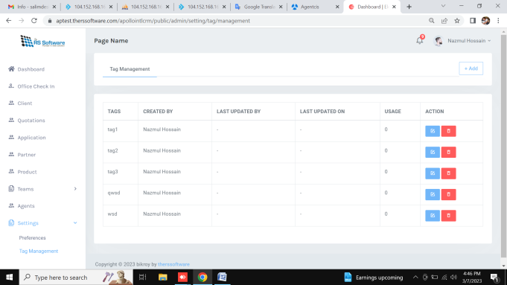

Settings Subscription & Billing (amount and date not change) ([link](https://aptest.therssoftware.com/apollointlcrm/public/admin/setting/subscription))

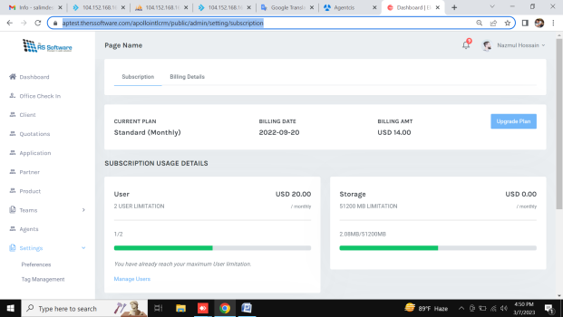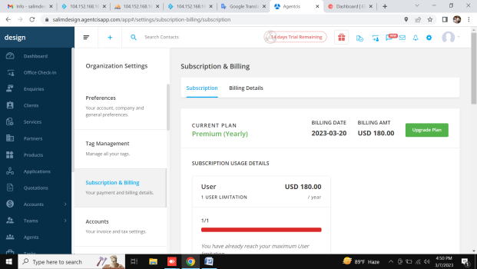

Done Settings Subscription & Billing ([link](https://aptest.therssoftware.com/apollointlcrm/public/admin/setting/subscription))

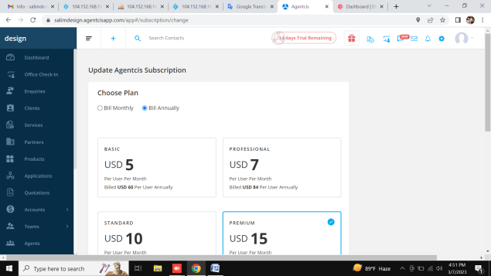 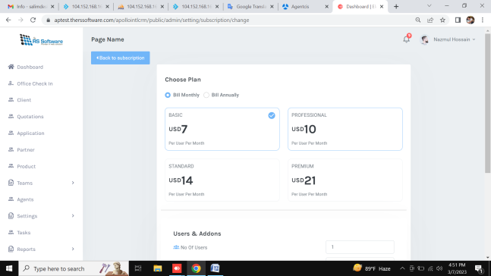

Done Settings Subscription & Billing ([link](https://aptest.therssoftware.com/apollointlcrm/public/admin/setting/subscription))

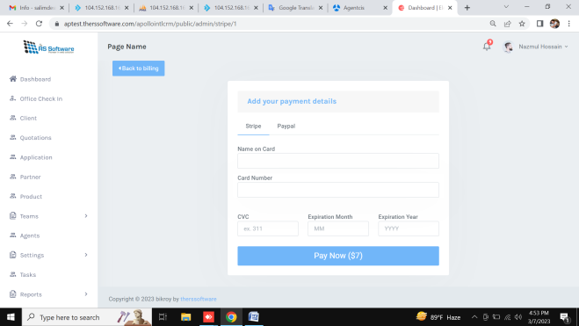 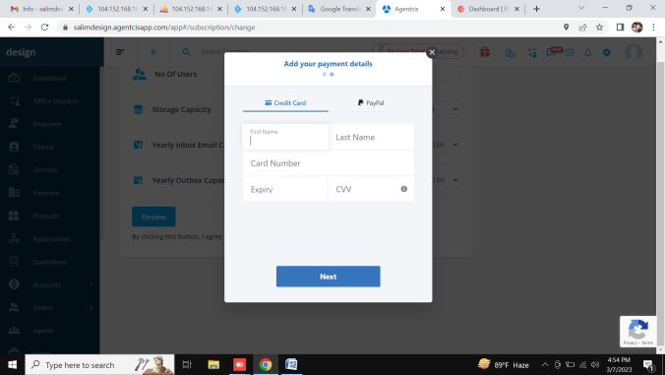

Done Settings Accounts ([link](https://aptest.therssoftware.com/apollointlcrm/public/admin/setting/subscription))

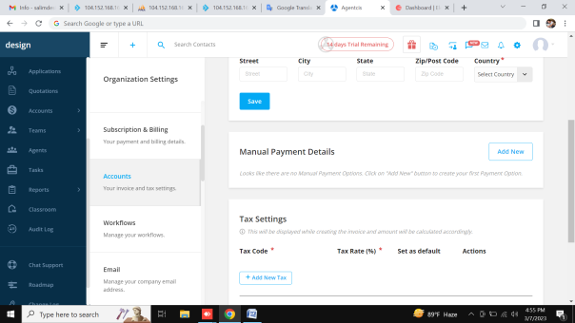 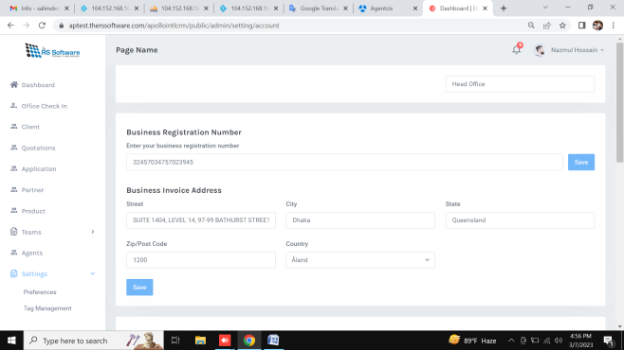

Done Workflows ([link](https://aptest.therssoftware.com/apollointlcrm/public/admin/setting/subscription))

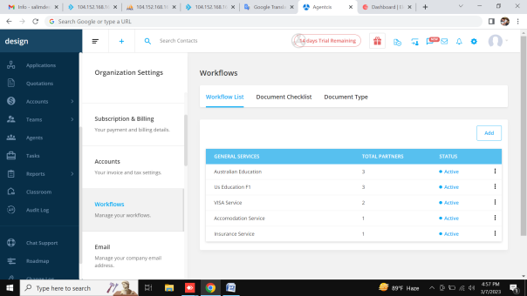 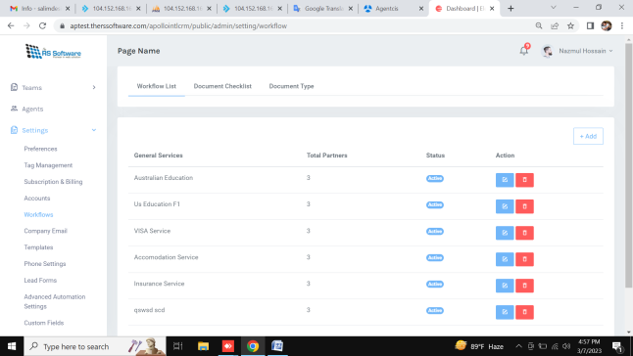

Done Settings Company Email ([link](https://aptest.therssoftware.com/apollointlcrm/public/admin/setting/email))

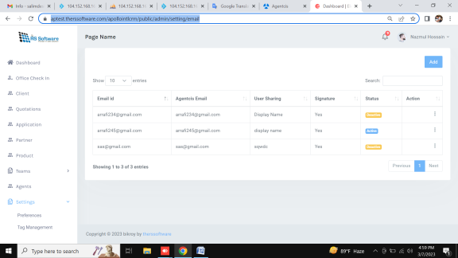 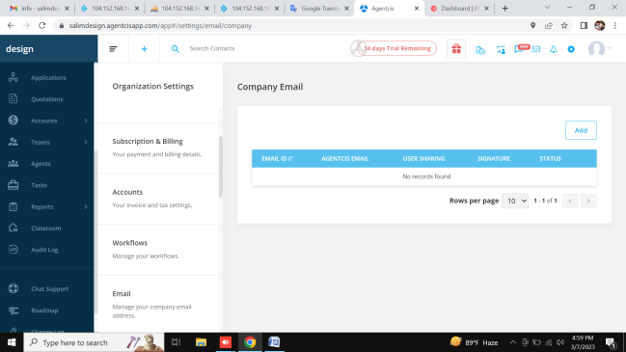

Done Settings Templates ([link](https://aptest.therssoftware.com/apollointlcrm/public/admin/setting/template/email))

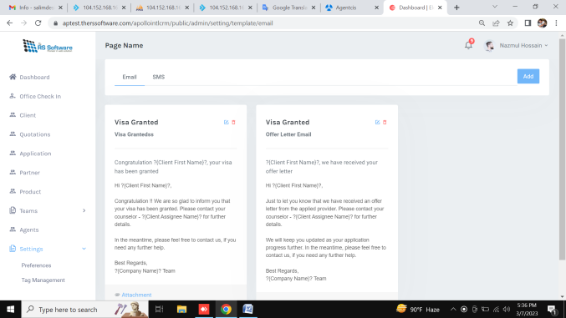 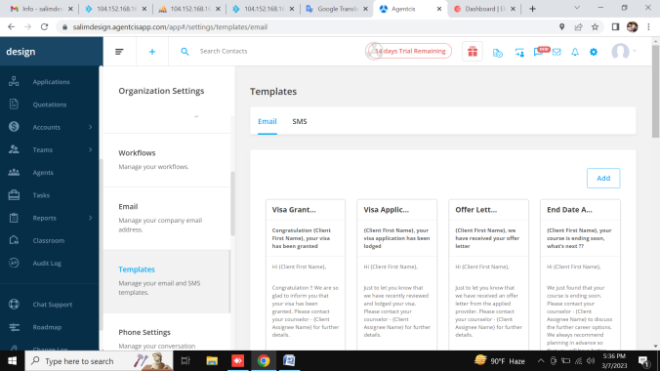

Settings Phone Settings not working ([link](https://aptest.therssoftware.com/apollointlcrm/public/admin/setting/phone/number))

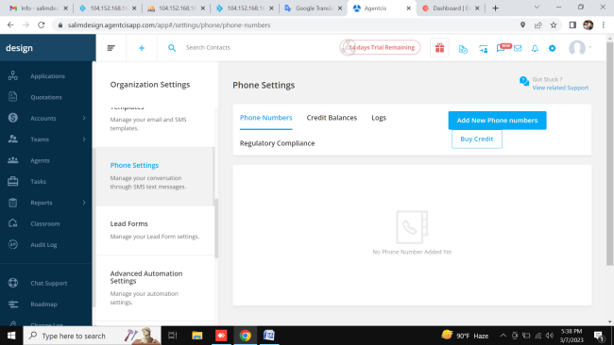 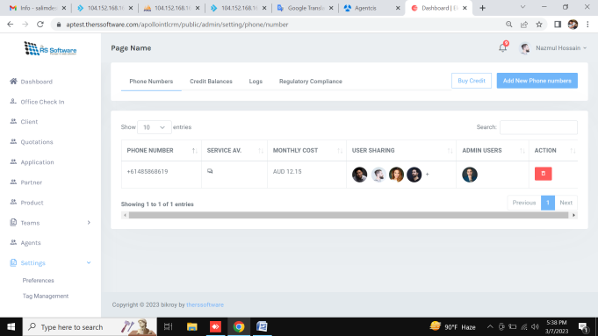

Done Settings leadform ([link](https://aptest.therssoftware.com/apollointlcrm/public/admin/setting/leadform))

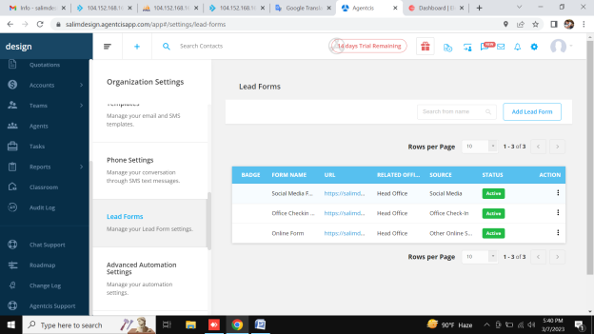 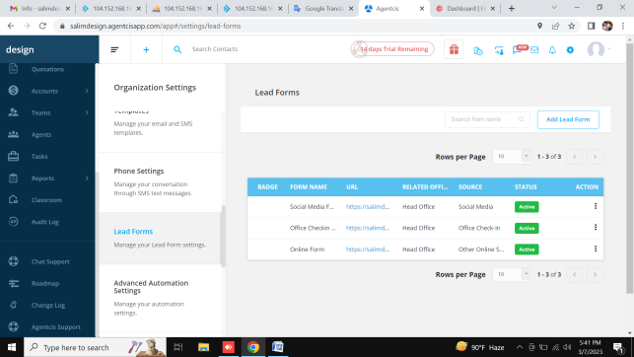

Settings automation not working ([link](https://aptest.therssoftware.com/apollointlcrm/public/admin/setting/leadform))

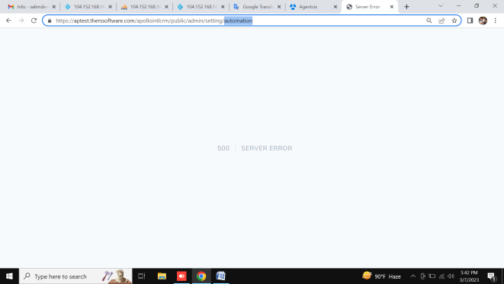 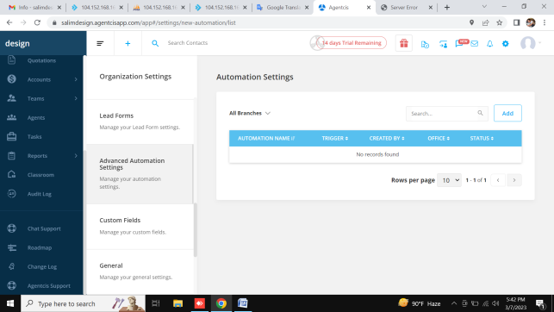

Settings Custom Fields not working ([link](https://aptest.therssoftware.com/apollointlcrm/public/admin/setting/customfield/client))

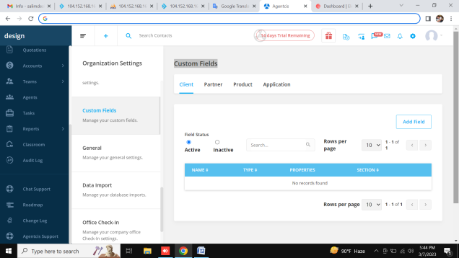 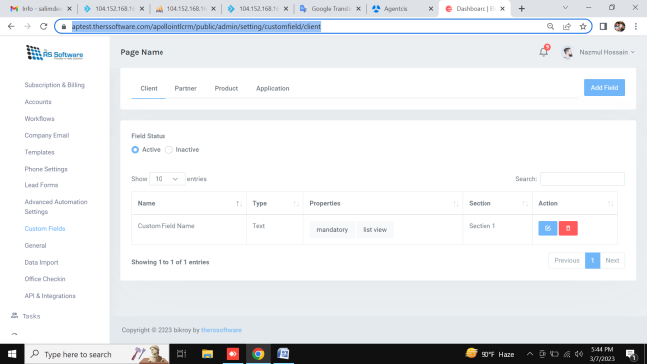

Done Settings General add edit ([link](https://aptest.therssoftware.com/apollointlcrm/public/admin/setting/customfield/client))

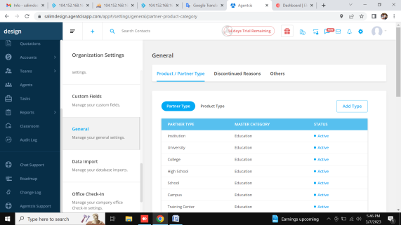 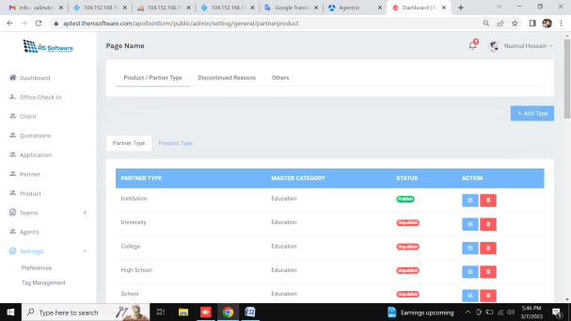

Settings General not apply product and partner type ([link](https://aptest.therssoftware.com/apollointlcrm/public/admin/partner/add))

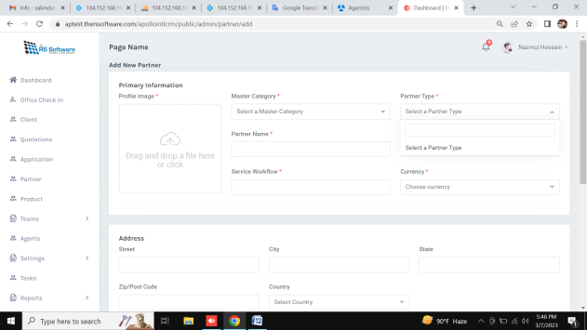 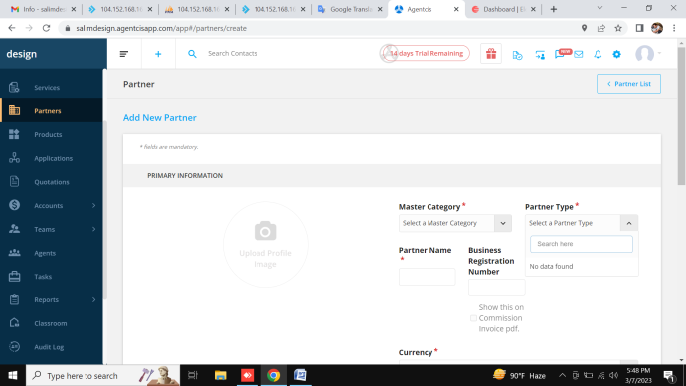

Settings Data Import not working ([link](https://aptest.therssoftware.com/apollointlcrm/public/admin/partner/add))

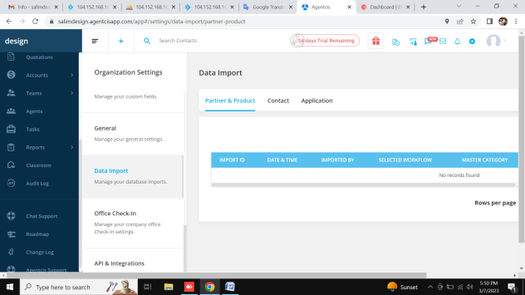 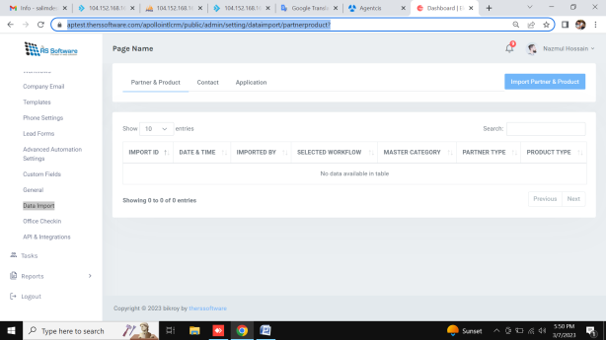

Settings Office Check-In not working ([link](https://aptest.therssoftware.com/apollointlcrm/public/admin/partner/add))

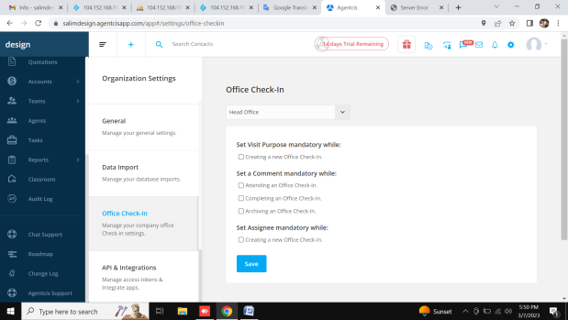 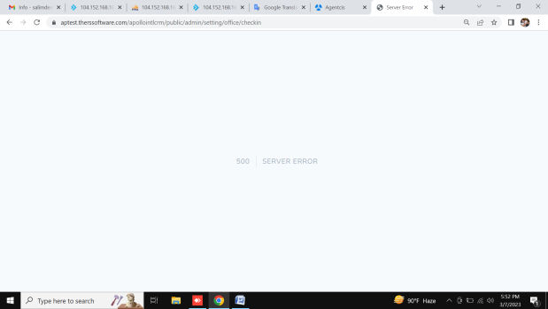

Settings Integrations not working ([link](https://aptest.therssoftware.com/apollointlcrm/public/admin/partner/add))

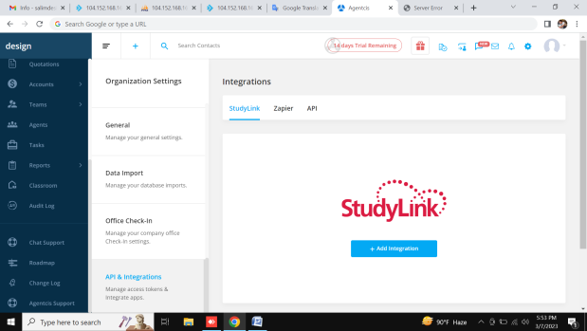

10. Tasks

Done Tasks

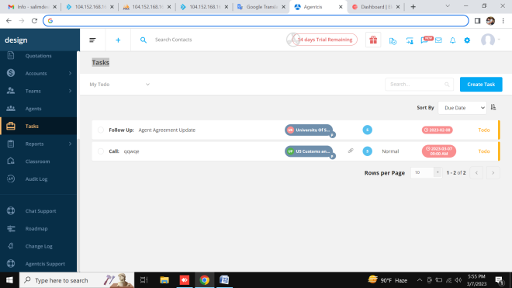 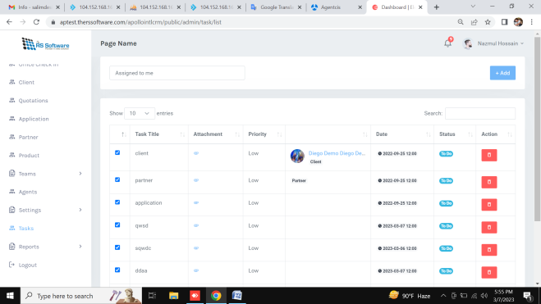

11. Client Reports

Client Reports any section not working

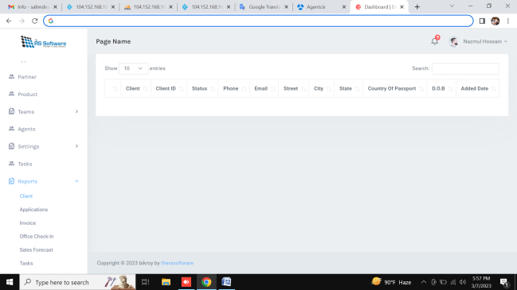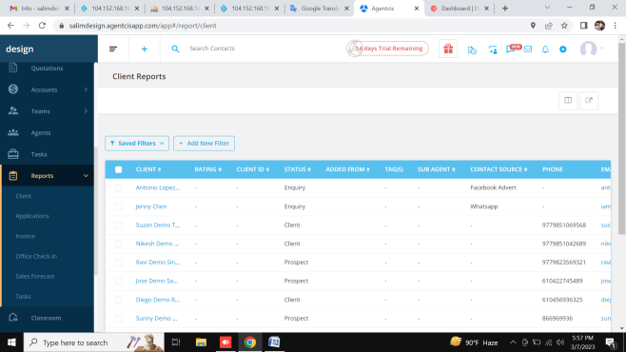

12. Classroom

13. Audit Logs